**Ideation Phase**

**Define the Problem Statements**

|  |  |
| --- | --- |
| Date | 31 January 2025 |
| Team ID | LTVIP2025TMID53108 |
| Project Name | FlightFinder |
| Maximum Marks | 2 Marks |

**Customer Problem Statement :**

**"Finding affordable and relevant flights is time-consuming, overwhelming, and often frustrating for travelers due to scattered information, outdated pricing, and lack of personalized search tools. Customers need a smarter, faster, and more intuitive way to discover flights that match their preferences in real-time."**

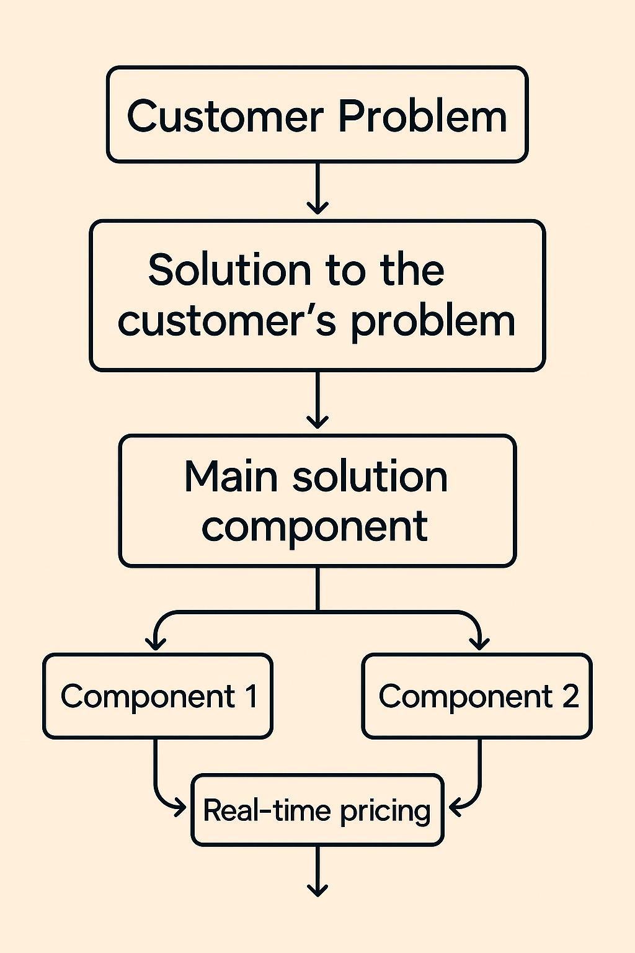

**Example:**

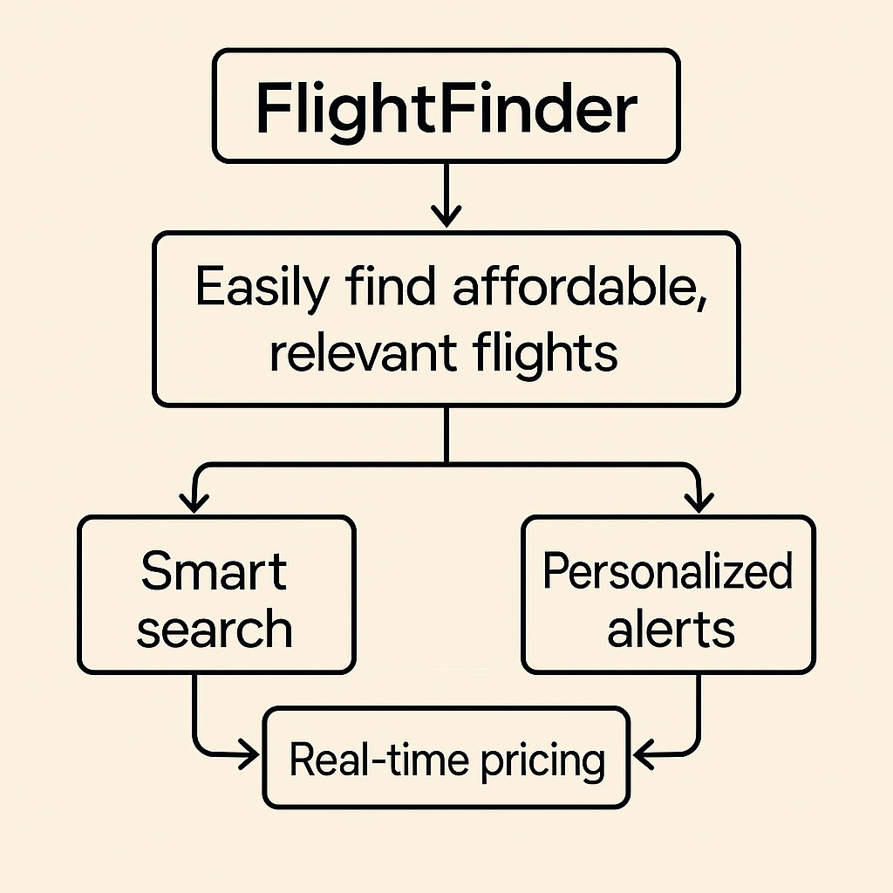

|  |  |  |  |  |  |
| --- | --- | --- | --- | --- | --- |
| **Problem Statement (PS)** | **I am (Customer)** | **I’m trying to** | **But** | **Because** | **Which makes me feel** |
| PS-1 |  |  |  |  |  |
| PS-2 |  |  |  |  |  |